Evaluator: Pontus Svensson

Reviewer: Leonardo Iwaya

‎‏Date 01/04/2024

TASK: Play the therapy games

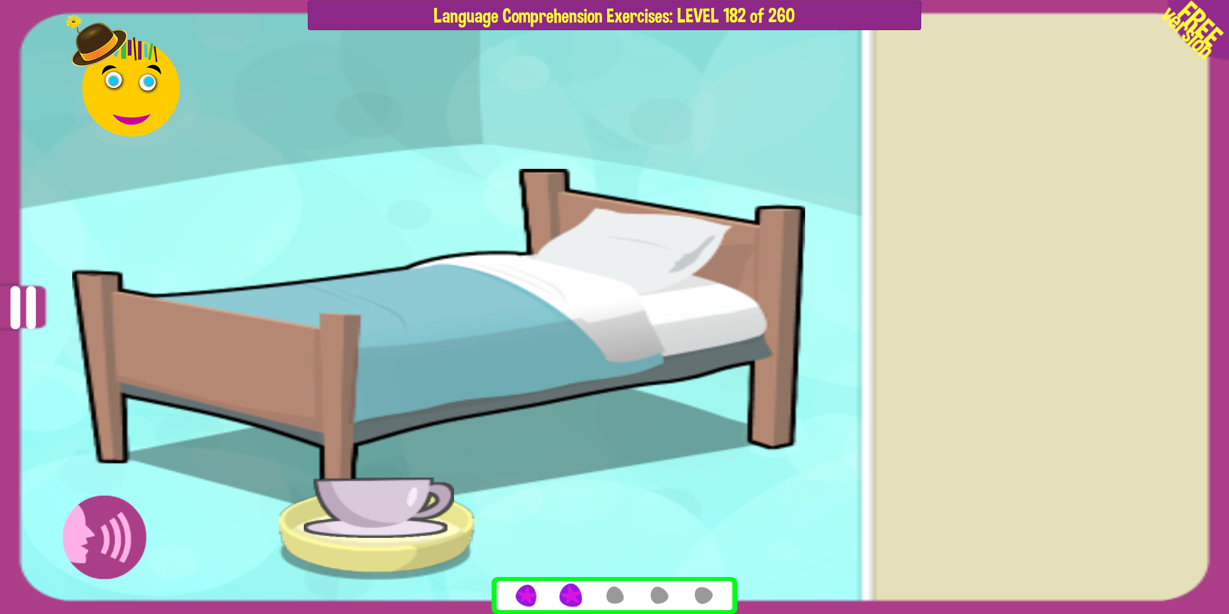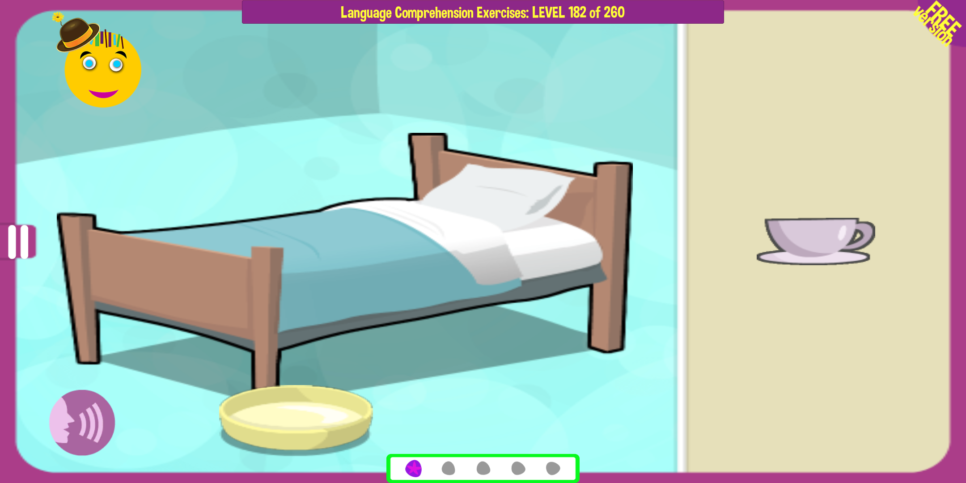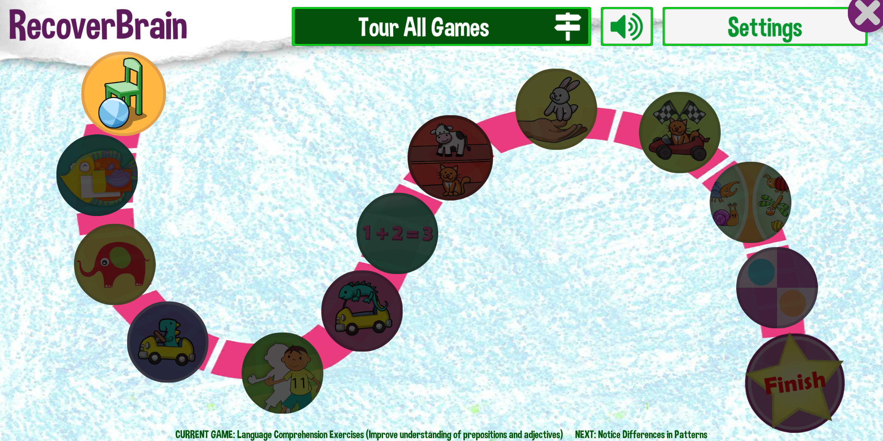

1. On the right, we can observe the sequence of events during gameplay across various game types. It is evident that instructions for each game are provided solely through audio, without any given text descriptions. This setup could pose difficulties for individuals with hearing impairments and contradicts heuristic six, **"recognition rather than recall,"** as it fails to provide assistance for users with reduced hearing.

2. When analyzing the screenshots from the game, we can see that the menu button is to the left. For someone unfamiliar or less knowledgeable of this type of setup, it might be hard to understand. This would violate heuristic number three, **“user control and freedom,”** as exit links should be easily discoverable. Additionally, this presents problems related to **"Consistency and Standards"** since the menu position changes over time in the app, and **"Visibility of system status"** because it is not clearly visible that there is a clickable button to open a menu there."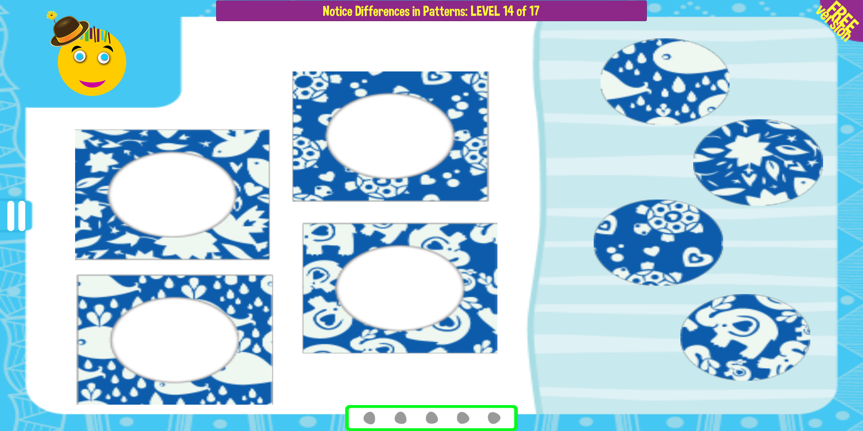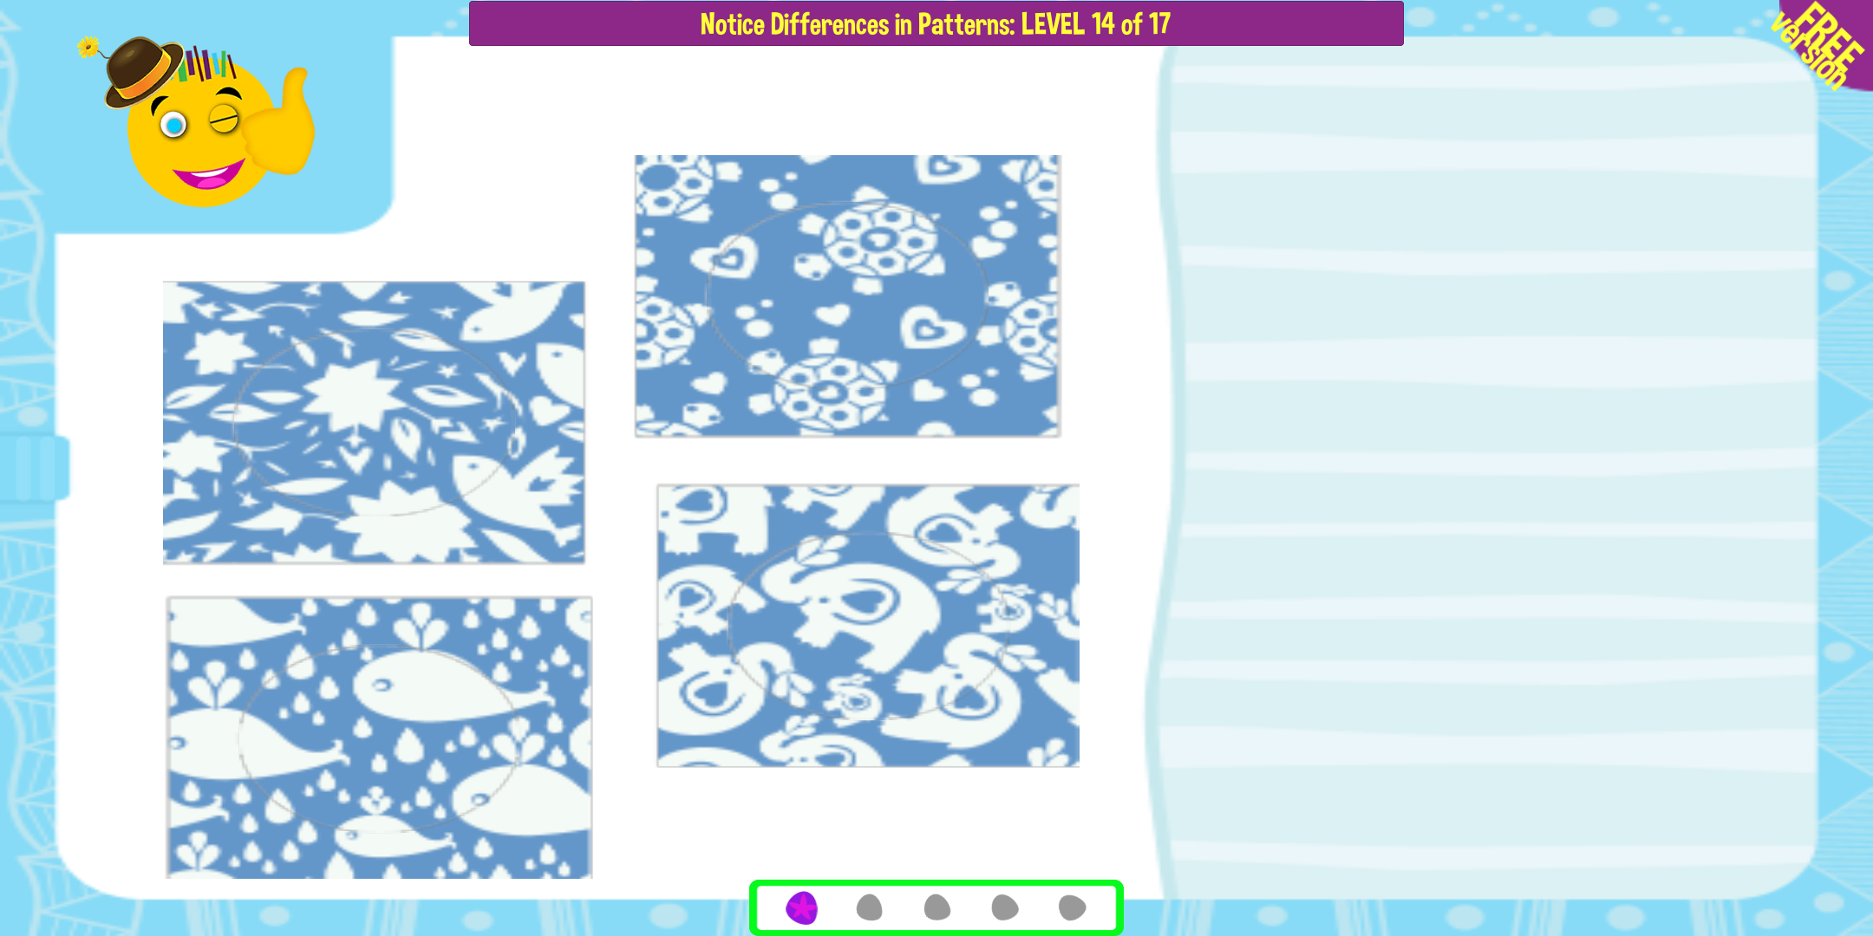

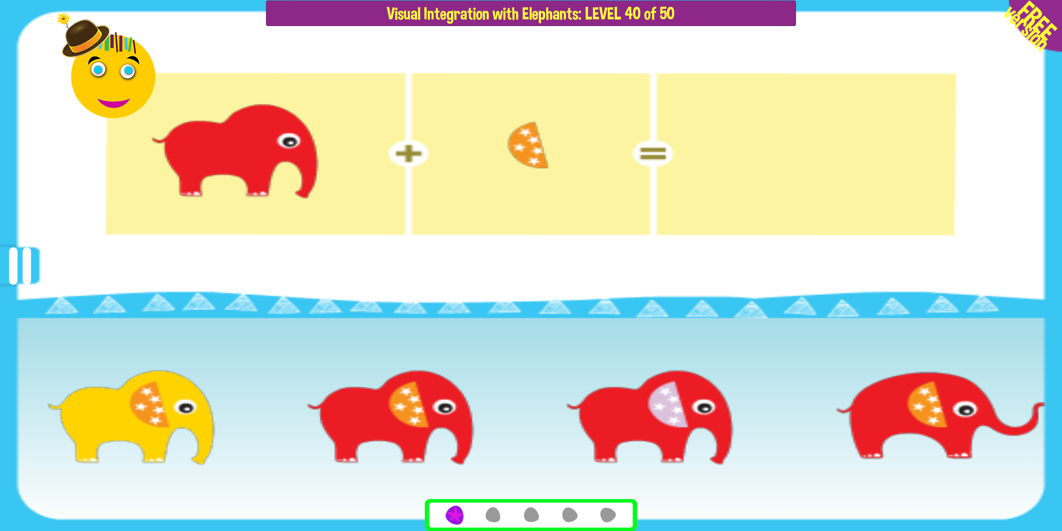

3. The app shows an excessive number of graphic elements, overly vibrant colors and interface controls (e.g., buttons, menus, progress bars) on virtually every screen. This excessive number of components violates the heuristic of **"Aesthetic and Minimalist Design."**

TASK: Fixing your settings.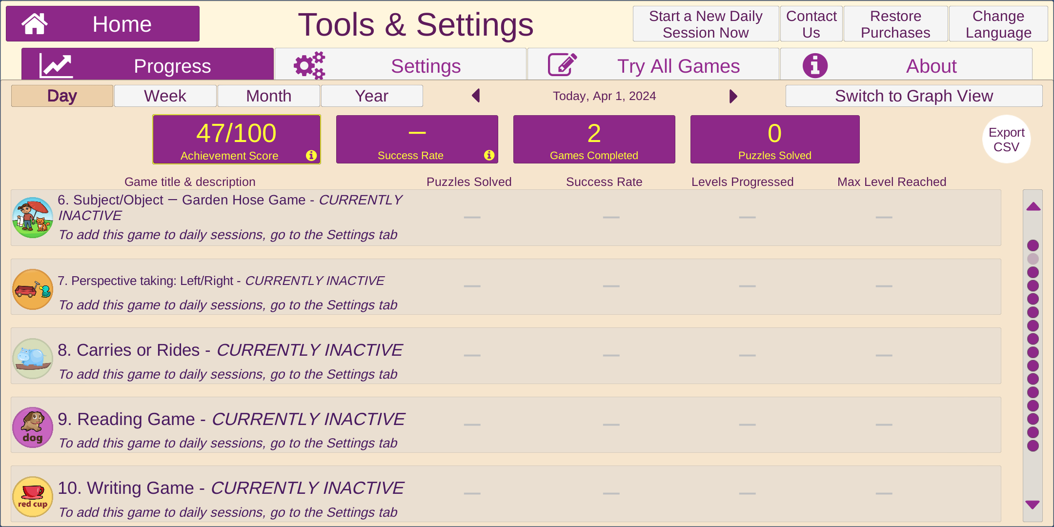

3. While we look at the “tools and settings” page, we can immediately see that the text size is quite small, which violates heuristic number eight, **visibility of system status**, as the information is not very visible.

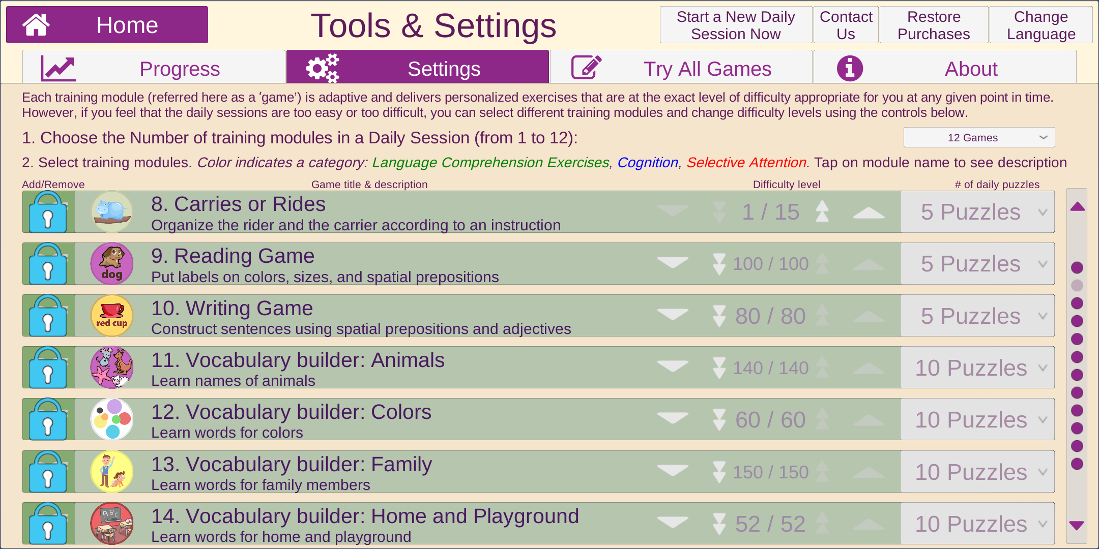

4. Upon examining the second screenshot, titled "Settings," we notice the option to adjust the difficulty level for each exercise. In addition to these settings, there are often other options available, such as customizing text size and color. However, the layout of the settings page deviates from the typical setup observed in standard settings pages. This deviation from standard practice may violate heuristic four, **consistency and standards**.

5. The app shows an excessive number of graphic elements, overly vibrant colors and interface controls (e.g., buttons, menus, progress bars) on virtually every screen. This excessive number of components violates the heuristic of **"Aesthetic and Minimalist Design."**

Other Remarks

One of the researchers reviewing the app felt dizzy while using the app, possibly due to the vibrant colors and use of blurry and complex patterns that need to be matched in one of the games (see the first Task).